Pima Indians Diabetes Classification
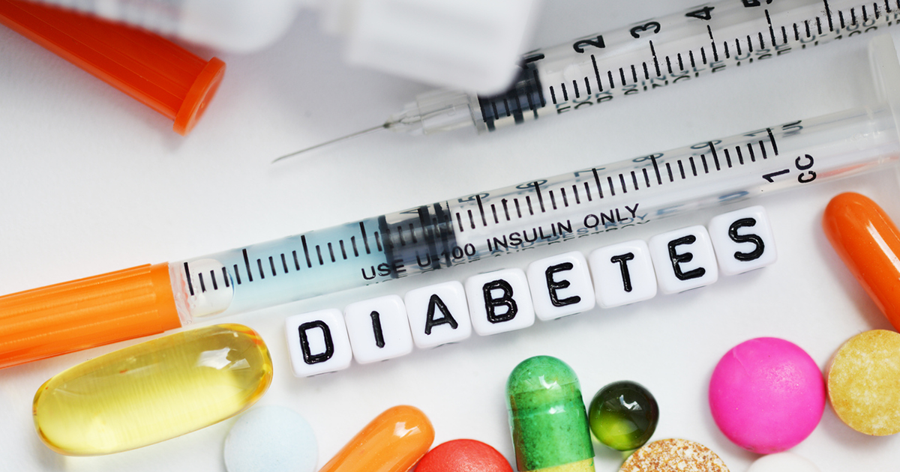
In order to study about the effects of unknown diseases on ethnicities at that point of time, case study of Pima Indians and Diabetes rises to the top of this list. Pima Indians, also known as the River People, lived around the Gila and Salt Rivers of Arizona. Agriculture was their strength and they consumed a diet filled with wheat, corn, beans, pumpkins, etc that was rich in fibers and vitamins. They also worked as cavalry scouts for Spanish and the US government. This generous and hard-working tribe has been heavily affected due to the irrigation systems built by the US government away from the Pima tribe. This led to a 40 year famine that broke down the Pima paradigms. Diabetes is greatly affected by diet, exercise and genetics. Due to this rough and enduring period, Pima community received a massive hit on it's diet and exercise as farming had been affected by the famines thus having an effect on the traditionaly rich diet. This dataset presents the opportunity to study the historical cause - effect on the Pima females and back it with numerical data.

Aim :
- To classify / predict whether a patient is prone to diabetes depending on multiple features.
- It is a binary classification with multiple numerical features.
Dataset Attributes

- Pregnancis : Number of times pregnant
- Glucose : Plasma glucose concentration a 2 hours in an oral glucose tolerance test
- BloodPressure : Diastolic blood pressure (mm Hg)
- SkinThickness : Triceps skin fold thickness (mm)
- Insulin : 2-Hour serum insulin (mu U/ml)
- BMI : Body mass index (weight in kg/(height in m)^2)
- DiabetesPedigreeFunction : Diabetes pedigree function
- Age : Age (years)
- Outcome : Class variable (0 or 1) 268 of 768 are 1, the others are 0

Notebook Contents :
- Dataset Information
- Exploratory Data Analysis (EDA)
- Summary of EDA
- Feature Engineering
- Modeling
- Conclusion

What you will learn :
- Data Visualization
- Data Scaling
- Statistical Tests for Feature Selection
- Modeling and visualization of results for algorithms
- Difference in model performances when trained on balanced and unbalanced data
- Stacking of classifiers

Related Work :
- Binary Classification : It is a discussion post that describes the approach required to deal with Binary Classification problems explained through notebooks that contain work done on datasets with easy and understandable code explanation!
- Time Series Analysis : It is a discussion post that describes the basics of Time Series Analysis explained through notebooks that contain work done on datasets with easy and understandable code explanation!
- Unsupervised Learning :It is a notebook that describes the work on Unsupervised Learning problem using K-Means clustering algorithm!

Lets get started!
Dataset Information

Import the Necessary Libraries :
In [1]:
import pandas as pdimport numpy as npimport matplotlib.pyplot as plt%matplotlib inlineimport seaborn as snspd.options.display.float_format = '{:.2f}'.formatimport warningswarnings.filterwarnings('ignore')
In [2]:
data = pd.read_csv('../input/pima-indians-diabetes-database/diabetes.csv')data.head()
Out[2]:
 | Pregnancies | Glucose | BloodPressure | SkinThickness | Insulin | BMI | DiabetesPedigreeFunction | Age | Outcome
0 | 6 | 148 | 72 | 35 | 0 | 33.60 | 0.63 | 50 | 1
1 | 1 | 85 | 66 | 29 | 0 | 26.60 | 0.35 | 31 | 0
2 | 8 | 183 | 64 | 0 | 0 | 23.30 | 0.67 | 32 | 1
3 | 1 | 89 | 66 | 23 | 94 | 28.10 | 0.17 | 21 | 0
4 | 0 | 137 | 40 | 35 | 168 | 43.10 | 2.29 | 33 | 1

Data Info :
In [3]:
data.shape
Out[3]:
(768, 9)
In [4]:
data.columns
Out[4]:
Index(['Pregnancies', 'Glucose', 'BloodPressure', 'SkinThickness', 'Insulin',
'BMI', 'DiabetesPedigreeFunction', 'Age', 'Outcome'],
dtype='object')
In [5]:
data.info()
<class 'pandas.core.frame.DataFrame'>
RangeIndex: 768 entries, 0 to 767
Data columns (total 9 columns):
# Column Non-Null Count Dtype
--- ------ -------------- -----
0 Pregnancies 768 non-null int64
1 Glucose 768 non-null int64
2 BloodPressure 768 non-null int64
3 SkinThickness 768 non-null int64
4 Insulin 768 non-null int64
5 BMI 768 non-null float64
6 DiabetesPedigreeFunction 768 non-null float64
7 Age 768 non-null int64
8 Outcome 768 non-null int64
dtypes: float64(2), int64(7)
memory usage: 54.1 KB
In [6]:
sns.heatmap(data.isnull(),cmap = 'magma',cbar = False);
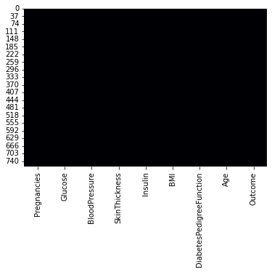
- No null values present in the data!
In [7]:
data.describe().T
Out[7]:
 | count | mean | std | min | 25% | 50% | 75% | max
Pregnancies | 768.00 | 3.85 | 3.37 | 0.00 | 1.00 | 3.00 | 6.00 | 17.00
Glucose | 768.00 | 120.89 | 31.97 | 0.00 | 99.00 | 117.00 | 140.25 | 199.00
BloodPressure | 768.00 | 69.11 | 19.36 | 0.00 | 62.00 | 72.00 | 80.00 | 122.00
SkinThickness | 768.00 | 20.54 | 15.95 | 0.00 | 0.00 | 23.00 | 32.00 | 99.00
Insulin | 768.00 | 79.80 | 115.24 | 0.00 | 0.00 | 30.50 | 127.25 | 846.00
BMI | 768.00 | 31.99 | 7.88 | 0.00 | 27.30 | 32.00 | 36.60 | 67.10
DiabetesPedigreeFunction | 768.00 | 0.47 | 0.33 | 0.08 | 0.24 | 0.37 | 0.63 | 2.42
Age | 768.00 | 33.24 | 11.76 | 21.00 | 24.00 | 29.00 | 41.00 | 81.00
Outcome | 768.00 | 0.35 | 0.48 | 0.00 | 0.00 | 0.00 | 1.00 | 1.00
In [8]:
colors = ['#446BAD','#A2A2A2']
diabetes = data[data['Outcome'] == 1].describe().Tnon_diabetes = data[data['Outcome'] == 0].describe().T
fig,ax = plt.subplots(nrows = 1,ncols = 2,figsize = (5,5))plt.subplot(1,2,1)sns.heatmap(diabetes[['mean']],annot = True,cmap = colors,linewidths = 0.4,linecolor = 'black',cbar = False,fmt = '.2f')plt.title('Diabetes');
plt.subplot(1,2,2)sns.heatmap(non_diabetes[['mean']],annot = True,cmap = colors,linewidths = 0.4,linecolor = 'black',cbar = False,fmt = '.2f',)plt.title('Non-Diabetes');
fig.tight_layout(pad = -1)
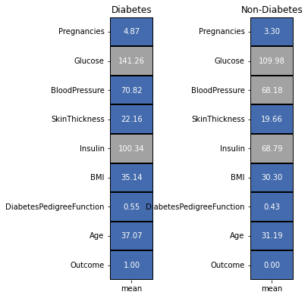
- Mean values of all the features for cases of diabetes and non-daibetes.
- Average number of Pregnancies detected for diabetes and non-diabetes cases is 4.87 & 3.30 respectively.
- Average Glucose values for diabetes cases, 141.26, is more than those found in non-diabetes cases, 109.98. This feature can form as a good indicator to predict the cases of diabetes.
- There is no significant difference in the average values of BloodPressure and SkinThickness between diabetes and non-diabetes cases.
- Just like Glucose, diabetes cases have higher average Insulin level, 100.34, than non-diabetes cases, 68.79.
- BMI is another feature that has higher values for diabetes cases than non-diabetes cases with 35.14 and 30.30 values respectively.
- Average DiabetesPedigreeFunction is slightly higher in diabetes cases, 0.55, than non-diabetes cases, 0.43.
- Mean Age values for cases of diabetes is 37.07 whereas that for non-diabetes cases is 31.19.
- From these mean values, we can say that some of the features display a clear cut difference between cases of diabetes and non-diabetes, however other features might require more effort to find their relationship with the target variable.
Exploratory Data Analysis

Dividing features into Numerical and Categorical :
In [9]:
col = list(data.columns)categorical_features = []numerical_features = []for i in col:
if len(data[i].unique()) > 6:
numerical_features.append(i)
else:
categorical_features.append(i)
print('Categorical Features :',*categorical_features)print('Numerical Features :',*numerical_features)
Categorical Features : Outcome
Numerical Features : Pregnancies Glucose BloodPressure SkinThickness Insulin BMI DiabetesPedigreeFunction Age
- Here, categorical features are defined if the the attribute has less than 6 unique elements else it is a numerical feature.
- Typical approach for this division of features can also be based on the datatypes of the elements of the respective attribute.
Eg : datatype = integer, attribute = numerical feature ; datatype = string, attribute = categorical feature
- For this dataset, as the number of features are less, we can manually check the dataset as well.
In [10]:
from sklearn.preprocessing import LabelEncoderle = LabelEncoder()df1 = data.copy(deep = True)
- Creating a deep copy of the orginal dataset and label encoding the text data of the categorical features.
- Modifications in the original dataset will not be highlighted in this deep copy.
- Hence, we use this deep copy of dataset that has all the features converted into numerical values for visualization & modeling purposes.

Categorical Features :

Distribution of Categorical Features :
In [11]:
plt.figure(figsize = (5,5))sns.distplot(data[categorical_features[0]],kde_kws = {'bw' : 1});title = 'Distribution : ' + categorical_features[0]plt.title(title);
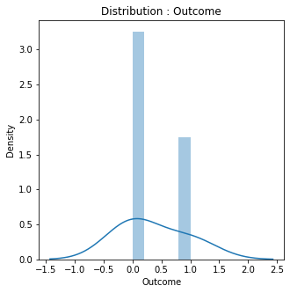
- Outcome displays a Normally Distributed data.

Numerical Features :

Distribution of Numerical Features :
In [12]:
fig, ax = plt.subplots(nrows = 4,ncols = 2,figsize = (10,20))for i in range(len(numerical_features)):
plt.subplot(4,2,i+1)
sns.distplot(data[numerical_features[i]])
title = 'Distribution : ' + numerical_features[i]
plt.title(title)plt.show()
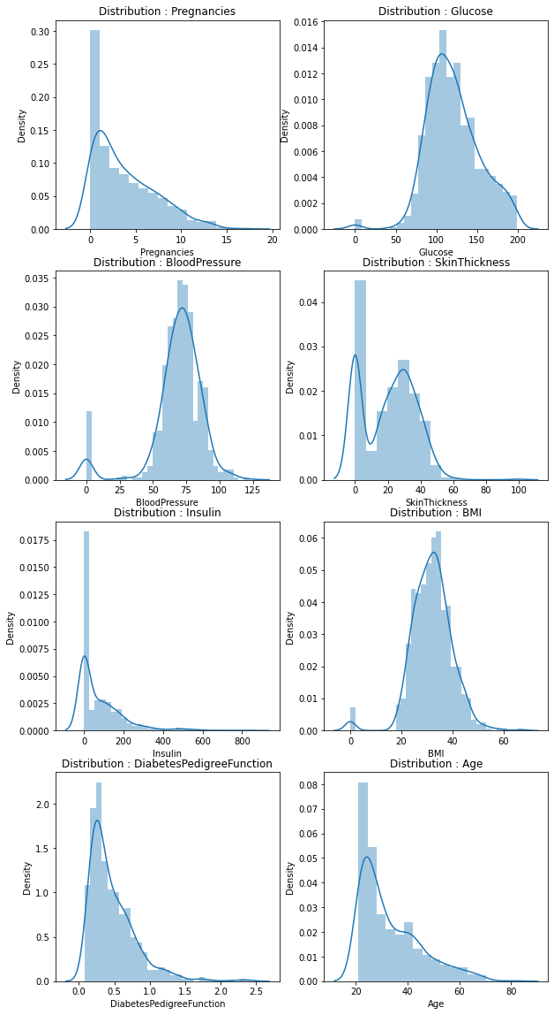
- Pregnancies, Insulin, DiabetesPedigreeFunction and Age have positively or rightly skewed data distribution.
- BloodPressure and Skin Thickness display a bidmodal data distribution.
- Data distributions of Glucose & BMI are a bit tricky. This is because they near about highlight a normal distribution or bimodal distribution. This is because of the small peak present at the value 0.
- For this notebook, we will consider these distributions as bimodal.

Target Variable Visualization (Outcome) :
In [13]:
l = list(data['Outcome'].value_counts())circle = [l[0] / sum(l) * 100,l[1] / sum(l) * 100]
fig = plt.subplots(nrows = 1,ncols = 2,figsize = (20,5))plt.subplot(1,2,1)plt.pie(circle,labels = ['Non-Diabetes Cases','Diabetes Cases'],autopct = '%1.1f%%',startangle = 90,explode = (0.1,0),colors = colors,
wedgeprops = {'edgecolor' : 'black','linewidth': 1,'antialiased' : True})plt.title('Diabetes - Non-Diabetes Case %');
plt.subplot(1,2,2)ax = sns.countplot('Outcome',data = data,palette = colors,edgecolor = 'black')for rect in ax.patches:
ax.text(rect.get_x() + rect.get_width() / 2, rect.get_height() + 2, rect.get_height(), horizontalalignment='center', fontsize = 11)ax.set_xticklabels(['Non-Diabetes Cases','Diabetes Cases'])
plt.title('Number of Diabetes - Non-Diabetes Cases');plt.show()
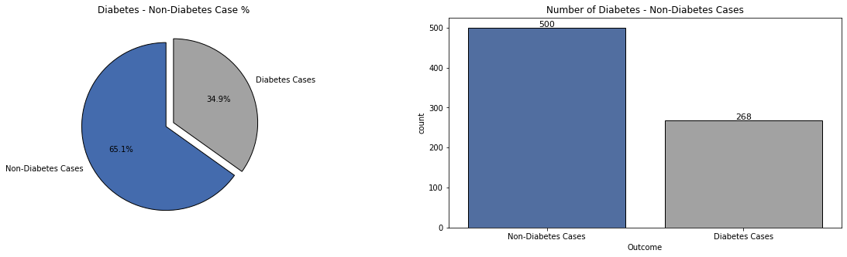
- The dataset is unbalanced in a 2 : 1 ratio for Non-Diabetes : Diabetes cases!
- Due to this, predictions will be biased towards Non-Diabetes cases.
- Visualizations will also display this bias, thus making it difficult to gain insights.

Numerical Features w.r.t Target Variable (Outcome) :
- Some of the numerical_features have too many unique values present in them. Thus, while visualizing, it was difficult to gain any insight from it.
- Hence, we divide the features into 2 parts only for visualization purposes :
  - Part 1 Features : Pregnancies, BloodPressure, SkinThickness, Age
  - Part 2 Features : Glucose, Insulin, BMI, DiabetesPedigreeFunction
In [14]:
l1 = ['Pregnancies','BloodPressure','SkinThickness','Age']l2 = [i for i in numerical_features if i not in l1]print('Part 1 Features : ',*l1)print('Part 2 Features : ',*l2)
Part 1 Features : Pregnancies BloodPressure SkinThickness Age
Part 2 Features : Glucose Insulin BMI DiabetesPedigreeFunction

Visualizing Part 1 Features w.r.t Outcome :
In [15]:
fig, ax = plt.subplots(nrows = 4,ncols = 1,figsize = (20,20))for i in range(len(l1)):
plt.subplot(4,1,i+1)
sns.countplot(l1[i],data = data,hue = "Outcome",palette = colors,edgecolor = 'black')
plt.legend(['Non-Diabetes Cases','Diabetes Cases'],loc = 'upper left')
title = l1[i] + ' w.r.t Outcome'
plt.title(title);
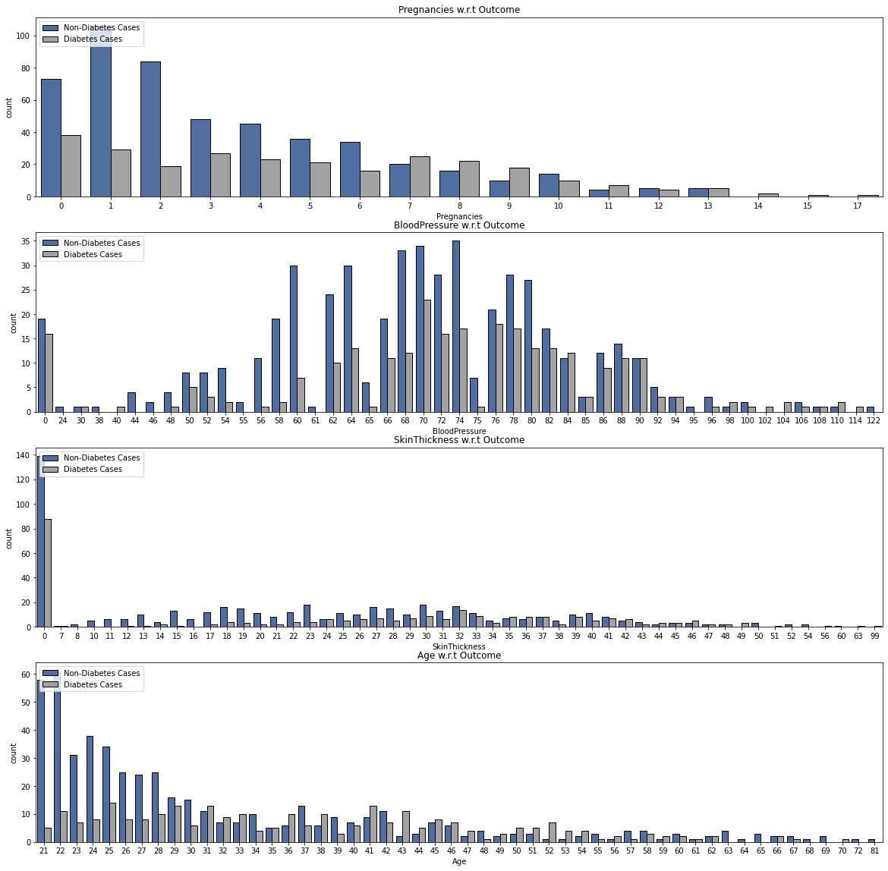
- For Pregnancies, cases of diabetes is present throughout the data. There is no specific range of values for which higher diabetes cases are found. Pregnancies range of values from 7 - 9 does highlight more cases of diabetes than non-diabetes for the 1st indicating a pattern but this claim gets rejected if we observe the values ahead.
- BloodPressure range of values 60 - 90 mm/hg highlights a high number of diabetes patients.
- SkinThickness displays very low number of diabetes cases for all the values. Out of those values, 24 - 42 has some prominent peaks of diabetes cases.
- When it comes to Age, young females are more prone to diabetes than older women. As the age increases, the number of diabetes cases have decreased. Age group 21 - 50 displays a higher probability of being diagnosed with diabetes.

Visualizing Part 2 Features w.r.t Outcome :
- Because of too many unique data points in the Part 2 Features, we will convert them into categorical features for understandable visualization and gaining insights purposes.
- Thus, we scale down the values of these features and bring the varied data points to a constant value. It represents a range of values.
- Here, we divide the data points of the numerical features and assign the resulting value as the representative constant for that data point. The scaling constants of 5, 10 & 100 are decided by looking into the data & intuition.
In [16]:
data['Glucose_Group'] = [ int(i / 5) for i in data['Glucose']]data['Insulin_Group'] = [ int(i / 50) for i in data['Insulin']]data['BMI_Group'] = [ int(i / 5) for i in data['BMI']]data['DiabetesPedigreeFunction_Group'] = [ int((i*100) / 5) for i in data['DiabetesPedigreeFunction']]
In [17]:
fig, ax = plt.subplots(nrows = 4,ncols = 1,figsize = (20,20))
group_numerical_features = [i + '_Group' for i in l2]for i in range(len(group_numerical_features)):
plt.subplot(4,1,i+1)
sns.countplot(group_numerical_features[i],data = data,hue = "Outcome",palette = colors,edgecolor = 'black')
plt.legend(['Non-Diabetes Cases','Diabetes Cases'],loc = 'upper left')
title = l2[i] + ' w.r.t Outcome'
plt.title(title);
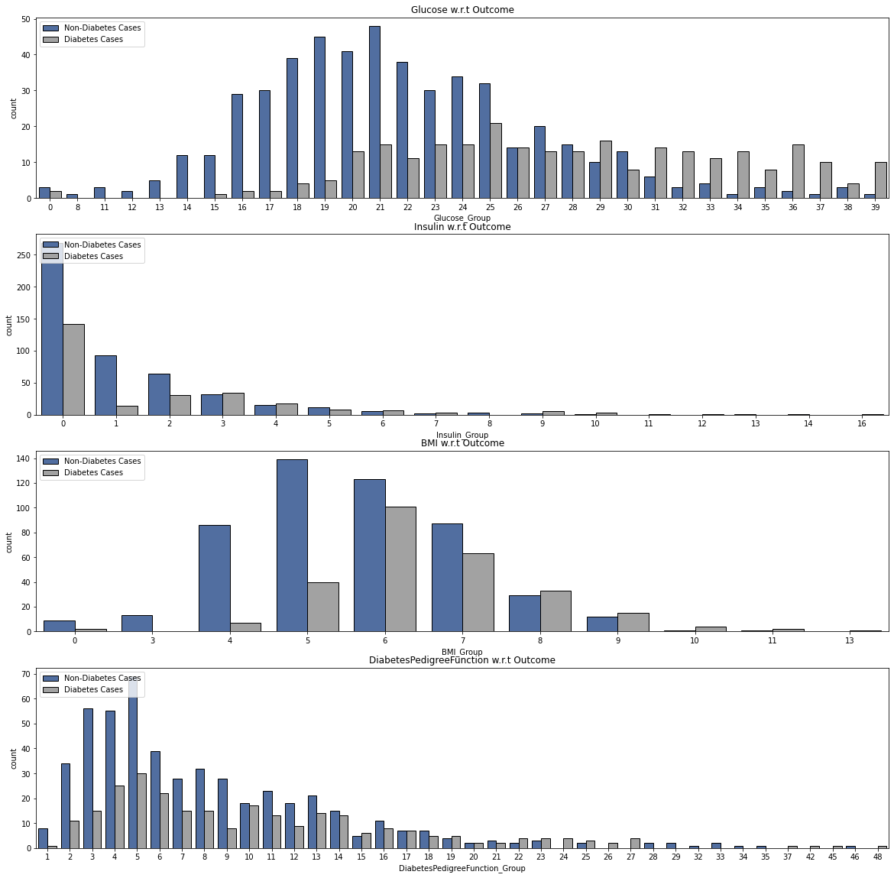
- From the Glucose group data, early values display very low number of diabetes cases. Cases then increase and become constant starting from 100 (20x5) - 195 (39x5).
- Insulin levels between 0 (0x50) - 300 mu U/ml (6x10) are highly susceptible to diabetes. Insulin's data distribution displays a high number of diabetes cases for value 0. This is probably because of the no data recorded for those females.
- For the BMI readings, diabetes cases have a higher probability for the range of values from 20 (4x5) - 45 kg/m^2 (9x5).
- DiabetesPedigreeFunction values also display positive diabetes cases throughout. 0.1 (2x5/100) - 1.25 (25x5/100) range of values have detected higher number of diabetes cases.

Numerical features vs Numerical features w.r.t Target variable (Outcome) :
In [18]:
a = 0fig,ax = plt.subplots(nrows = 14,ncols = 2,figsize = (25,60))for i in range(len(numerical_features)):
for j in range(len(numerical_features)):
if i != j and j > i:
a += 1
plt.subplot(14,2,a)
sns.scatterplot(x = numerical_features[i],y = numerical_features[j],data = data,hue = 'Outcome',palette = colors,edgecolor = 'black');
plt.legend(['Non-Diabetes','Diabetes'],loc = 'upper left',)
title = numerical_features[i] + ' vs ' + numerical_features[j]
plt.title(title)
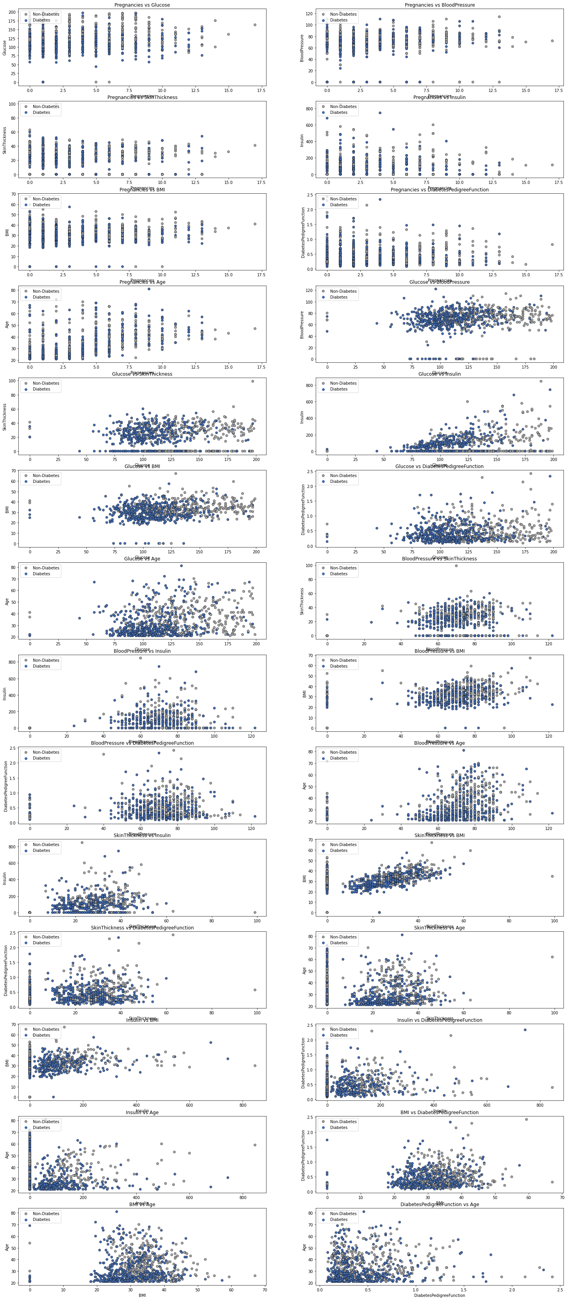
- Pregnancies with values between 7 - 10 have high chances of diabetes. This range does not display a complete dominance but it has some presence.
- Glucose values higher than 125 indicate very high chances of diabetes.
- BloodPressure values between 60 - 100 highlight many cases of diabetes coupled with any feature.
- When both, BMI and SkinThickness, feature values are between 20 - 50, probability of diabetes is very high.
- Insulin values between 0 - 300 increases the risk of diabetes. When above 400, the female has a sure shot chance of being diabetic.
- For Age group of 20 - 50 as well as DiabetesPedigreeFunction values ranging from 0 - 1.5 results in a diabetic condition.
Summary of EDA

Order / Values of features for positive cases of heart disease :
- Numerical Features (Range) :
  - Pregnancies : 7 - 10
  - Glucose : 125+
  - BloodPressure : 60 - 100
  - SkinThickness : 20 - 50
  - Insulin : 0 - 300
  - BMI : 20 - 50
  - DiabetesPedigreeFunction : 0 - 1.5
  - Age : 20 - 50
According to the data, these order / range of values leads to heart failures.
Domain Information

Numerical Features :

  - Pregnancies : Gestational diabetes is a type of diabetes that can develop during pregnancy in women who don't already have diabetes. Typically, diabetic conditions causes issues in pregnancy leading to defects in babies.
  - Glucose : A reading of more than 200 mg/dL after 2 hours means you have diabetes. Higher glucose in blood i.e high blood sugar, can lead to diabetes.
  - BloodPressure : Diabetes can cause high blood pressure leading to various health issues. High blood pressure might lead to type 2 diabetes because of hypertension. Value of blood pressure leading to diabetes is around 130/80.
  - SkinThickness : Skin thickness is found in diabetic patients due to collagen content. Some rashes do appear as well but it is not to come out as a result of diabetes.
  - Insulin : It is used to regulate the blood sugar levels in the body. It can play a part in developing type 2 diabetes. Insulin readings higher than 125 indicate strong chances of diabetic conditions.
  - BMI : It is an indication about your general body health. Higher the BMI levels, more is the obesity and thus leads to type 2 diabetes. Usually, value above 30 may prompt towards diabetes.
  - DiabetesPedigreeFunction : It is function that indicates the likelihood of diabetes based on family history. Higher the value, more is the plasma glucose levels, hence increases the chances of diabetes.
  - Age : Diabetes can be developed at any age.
- All the information mentioned is gathered from websites and research papers. We will use this information for cross checking the summary of EDA and feature selection.
- Range of values obtained from the EDA slightly miss match the Domain Information for the features : Glucose, BloodPressure and Insulin.
- Thus, we will carry out the feature engineering process, balance the dataset using SMOTE analysis and record the difference between the model performances when trained on balanced and unbalanced datasets.
Feature Engineering

Data Scaling :
In [19]:
from sklearn.preprocessing import MinMaxScaler,StandardScalermms = MinMaxScaler() # Normalizationss = StandardScaler() # Standardization
df1 = data.copy(deep = True)df1.drop(columns = ['Glucose_Group','Insulin_Group','BMI_Group','DiabetesPedigreeFunction_Group'],inplace = True)
df1['Pregnancies'] = mms.fit_transform(df1[['Pregnancies']])df1['Insulin'] = ss.fit_transform(df1[['Insulin']])df1['DiabetesPedigreeFunction'] = ss.fit_transform(df1[['DiabetesPedigreeFunction']])df1['Age'] = ss.fit_transform(df1[['Age']])df1['BloodPressure'] = ss.fit_transform(df1[['BloodPressure']])df1['SkinThickness'] = ss.fit_transform(df1[['SkinThickness']])df1['Glucose'] = ss.fit_transform(df1[['Glucose']])df1['BMI'] = ss.fit_transform(df1[['BMI']])df1.head()
Out[19]:
 | Pregnancies | Glucose | BloodPressure | SkinThickness | Insulin | BMI | DiabetesPedigreeFunction | Age | Outcome
0 | 0.35 | 0.85 | 0.15 | 0.91 | -0.69 | 0.20 | 0.47 | 1.43 | 1
1 | 0.06 | -1.12 | -0.16 | 0.53 | -0.69 | -0.68 | -0.37 | -0.19 | 0
2 | 0.47 | 1.94 | -0.26 | -1.29 | -0.69 | -1.10 | 0.60 | -0.11 | 1
3 | 0.06 | -1.00 | -0.16 | 0.15 | 0.12 | -0.49 | -0.92 | -1.04 | 0
4 | 0.00 | 0.50 | -1.50 | 0.91 | 0.77 | 1.41 | 5.48 | -0.02 | 1
- Machine learning model does not understand the units of the values of the features. It treats the input just as a simple number but does not understand the true meaning of that value. Thus, it becomes necessary to scale the data.
Eg : Age = Years; FastingBS = mg / dl
- We have 2 options for data scaling : 1) Normalization 2) Standardization. As most of the algorithms assume the data to be normally (Gaussian) distributed, Normalization is done for features whose data does not display normal distribution and standardization is carried out for features that are normally distributed where their values are huge or very small as compared to other features.

Normalization : Pregnancies, Insulin, DiabetesPedigreeFunction and Age features are normalized as they displayed a right skewed data distribution. BloodPressure, Skin Thickness, Glucose & BMI highlight a bidmodal data distribution.

Standardization : None of the features are standardized for the above data.

Correlation Matrix :
In [20]:
plt.figure(figsize = (20,5))sns.heatmap(df1.corr(),cmap = colors,annot = True);
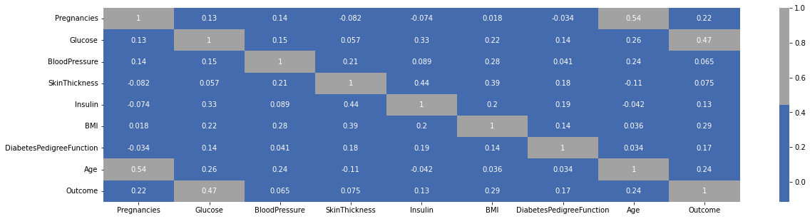
- It is a huge matrix with too many features. We will check the correlation only with respect to Outcome.
In [21]:
corr = df1.corrwith(df1['Outcome']).sort_values(ascending = False).to_frame()corr.columns = ['Correlations']plt.subplots(figsize = (5,5))sns.heatmap(corr,annot = True,cmap = colors,linewidths = 0.4,linecolor = 'black');plt.title('Correlation w.r.t Outcome');
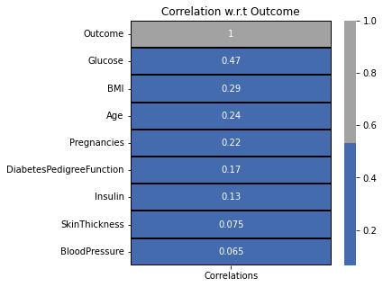
- SkinThickness and BloodPressure does not display any kind of correlation.
- Glucose displays the highest positive correlation with Outcome. It is followed by BMI, Age, Pregnancies, DiabetesPedigreeFunction & Insulin!

Feature Selection for Numerical Features :
In [22]:
from sklearn.feature_selection import SelectKBestfrom sklearn.feature_selection import f_classif

ANOVA Test :
In [23]:
features = df1.loc[:,numerical_features]target = df1.loc[:,categorical_features]
best_features = SelectKBest(score_func = f_classif,k = 'all')fit = best_features.fit(features,target)
featureScores = pd.DataFrame(data = fit.scores_,index = list(features.columns),columns = ['ANOVA Score'])
plt.subplots(figsize = (5,5))sns.heatmap(featureScores.sort_values(ascending = False,by = 'ANOVA Score'),annot = True,cmap = colors,linewidths = 0.4,linecolor = 'black',fmt = '.2f');plt.title('Selection of Numerical Features');
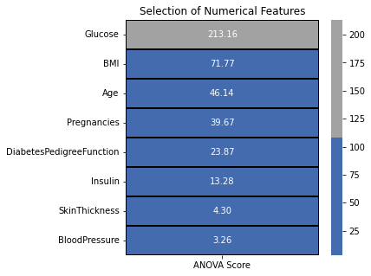
- According to the ANOVA test, higher the value of the ANOVA score, more is the importance of the feature.
- From the above results, we need to drop SkinThickness & BloodPressure. We will take the remaining features into consideration for modeling.
In [24]:
df1.drop(columns = ['SkinThickness','BloodPressure'],inplace = True)f1 = df1.iloc[:,:6].valuest1 = df1.iloc[:,6].values
df2 = df1.copy(deep = True)df2.head()
Out[24]:
 | Pregnancies | Glucose | Insulin | BMI | DiabetesPedigreeFunction | Age | Outcome
0 | 0.35 | 0.85 | -0.69 | 0.20 | 0.47 | 1.43 | 1
1 | 0.06 | -1.12 | -0.69 | -0.68 | -0.37 | -0.19 | 0
2 | 0.47 | 1.94 | -0.69 | -1.10 | 0.60 | -0.11 | 1
3 | 0.06 | -1.00 | 0.12 | -0.49 | -0.92 | -1.04 | 0
4 | 0.00 | 0.50 | 0.77 | 1.41 | 5.48 | -0.02 | 1
- Creating a deep copy of the orginal dataset.
- This is done in order to highlight the model performances when trained on balanced and unbalanced datasets.
We will now move onto data balancing!

Data Balancing using SMOTE :

In order to cope with unbalanced data, there are 2 options :

  - Undersampling : Trim down the majority samples of the target variable.
  - Oversampling : Increase the minority samples of the target variable to the majority samples.
- In this case, we will oversample the minority class.
- For data balancing, we will use imblearn.
  - pip statement : pip install imbalanced-learn
- Due to the use of synthetic data, we cannot evaluate the models using accuracy. We have duplicated the data, thus using accuracy would be misleading to evaluate the model.
- We will use the confusion matrix, ROC-AUC graph-score for model evaluation. ROC-AUC gives us the relation between True Positive and False Positive rate.
In [25]:
import imblearnfrom collections import Counterfrom imblearn.over_sampling import SMOTE
In [26]:
over = SMOTE()f2 = df1.iloc[:,:6].valuest2 = df1.iloc[:,6].valuesf2, t2 = over.fit_resample(f2, t2)Counter(t2)
Out[26]:
Counter({1: 500, 0: 500})
Modeling

In [27]:
from sklearn.model_selection import train_test_splitfrom sklearn.metrics import confusion_matrixfrom sklearn.metrics import roc_auc_scorefrom sklearn.metrics import plot_roc_curvefrom sklearn.model_selection import cross_val_scorefrom sklearn.model_selection import GridSearchCVfrom sklearn.metrics import classification_reportfrom sklearn.metrics import accuracy_scorefrom sklearn.model_selection import RepeatedStratifiedKFoldfrom sklearn.metrics import precision_recall_curve
In [28]:
x_train1, x_test1, y_train1, y_test1 = train_test_split(f1, t1, test_size = 0.25, random_state = 2) # Unbalancedx_train2, x_test2, y_train2, y_test2 = train_test_split(f2, t2, test_size = 0.25, random_state = 2) # Balanced
- Selecting the features from the above conducted tests and splitting the data into 75 - 25 train - test groups.
In [29]:
def model(classifier,x_train,y_train,x_test,y_test):

classifier.fit(x_train,y_train)
prediction = classifier.predict(x_test)
cv = RepeatedStratifiedKFold(n_splits = 10,n_repeats = 3,random_state = 1)
print("Cross Validation Score : ",'{0:.2%}'.format(cross_val_score(classifier,x_train,y_train,cv = cv,scoring = 'roc_auc').mean()))
print("ROC_AUC Score : ",'{0:.2%}'.format(roc_auc_score(y_test,prediction)))
plot_roc_curve(classifier, x_test,y_test)
plt.title('ROC_AUC_Plot')
plt.show()
def model_evaluation(classifier,x_test,y_test):

# Confusion Matrix
cm = confusion_matrix(y_test,classifier.predict(x_test))
names = ['True Neg','False Pos','False Neg','True Pos']
counts = [value for value in cm.flatten()]
percentages = ['{0:.2%}'.format(value) for value in cm.flatten()/np.sum(cm)]
labels = [f'{v1}\n{v2}\n{v3}' for v1, v2, v3 in zip(names,counts,percentages)]
labels = np.asarray(labels).reshape(2,2)
sns.heatmap(cm,annot = labels,cmap = 'Blues',fmt ='')

# Classification Report
print(classification_report(y_test,classifier.predict(x_test)))

1] Xgboost Classifier :
In [30]:
from xgboost import XGBClassifier
classifier_xgb = XGBClassifier(learning_rate= 0.01,max_depth = 3,n_estimators = 1000)
- #### Unbalanced Dataset :
In [31]:
model(classifier_xgb,x_train1,y_train1,x_test1,y_test1)model_evaluation(classifier_xgb,x_test1,y_test1)
Cross Validation Score : 83.60%
ROC_AUC Score : 67.16%
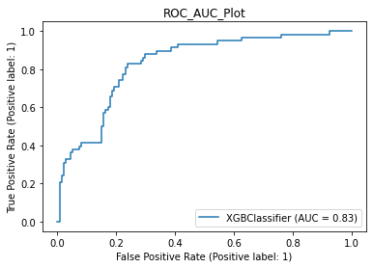
precision recall f1-score support

0 0.80 0.84 0.82 134
1 0.58 0.50 0.54 58

accuracy 0.74 192
macro avg 0.69 0.67 0.68 192
weighted avg 0.73 0.74 0.73 192

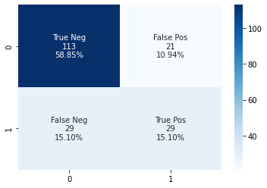
- #### Balanced Dataset :
In [32]:
model(classifier_xgb,x_train2,y_train2,x_test2,y_test2)model_evaluation(classifier_xgb,x_test2,y_test2)
Cross Validation Score : 86.71%
ROC_AUC Score : 78.60%
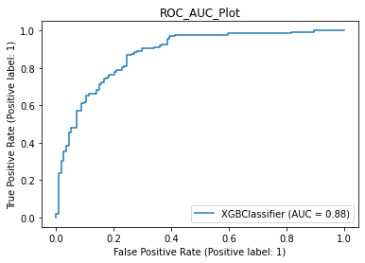
precision recall f1-score support

0 0.77 0.76 0.77 114
1 0.80 0.81 0.81 136

accuracy 0.79 250
macro avg 0.79 0.79 0.79 250
weighted avg 0.79 0.79 0.79 250

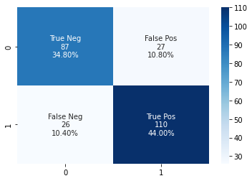

2] LightGBM Classifier :
In [33]:
from lightgbm import LGBMClassifier
classifier_lgbm = LGBMClassifier(learning_rate= 0.01,max_depth = 3,n_estimators = 1000)
- #### Unbalanced Dataset :
In [34]:
model(classifier_lgbm,x_train1,y_train1,x_test1,y_test1)model_evaluation(classifier_lgbm,x_test1,y_test1)
Cross Validation Score : 82.36%
ROC_AUC Score : 64.20%
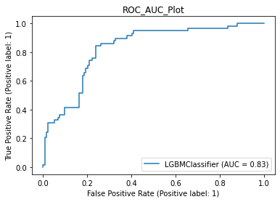
precision recall f1-score support

0 0.78 0.84 0.81 134
1 0.54 0.45 0.49 58

accuracy 0.72 192
macro avg 0.66 0.64 0.65 192
weighted avg 0.71 0.72 0.71 192

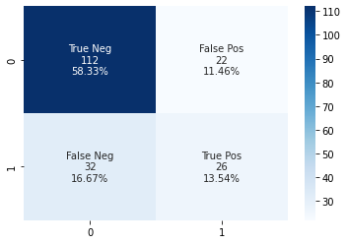
- #### Balanced Dataset :
In [35]:
model(classifier_lgbm,x_train2,y_train2,x_test2,y_test2)model_evaluation(classifier_lgbm,x_test2,y_test2)
Cross Validation Score : 86.21%
ROC_AUC Score : 77.43%
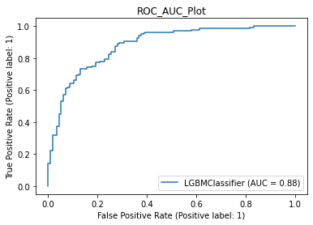
precision recall f1-score support

0 0.75 0.75 0.75 114
1 0.79 0.79 0.79 136

accuracy 0.78 250
macro avg 0.77 0.77 0.77 250
weighted avg 0.78 0.78 0.78 250

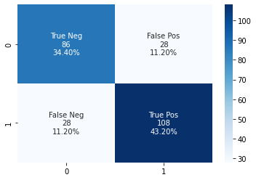

3] Stack of XGBClassifier and LightGBMClassifier :
In [36]:
from sklearn.ensemble import StackingClassifier
stack = StackingClassifier(estimators = [('classifier_xgb',classifier_xgb),
('classifier_lgbm',classifier_lgbm)],
final_estimator = classifier_lgbm)
- For stacking of classifiers, we stack the above 2 classifiers :
  - XGBClassifier
  - LightGBMClassifier
- It has an important hyperparameter known as final_estimator. It is the final classifier that makes the final prediction by using the predicted classes by the various classifier and predicts the final output.
- #### Unbalanced Dataset :
In [37]:
model(stack,x_train1,y_train1,x_test1,y_test1)model_evaluation(stack,x_test1,y_test1)
Cross Validation Score : 80.15%
ROC_AUC Score : 65.70%
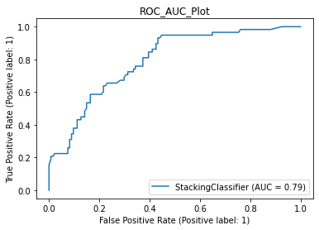
precision recall f1-score support

0 0.78 0.87 0.82 134
1 0.59 0.45 0.51 58

accuracy 0.74 192
macro avg 0.69 0.66 0.67 192
weighted avg 0.73 0.74 0.73 192

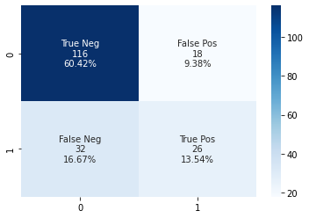
- #### Balanced Dataset :
In [38]:
model(stack,x_train2,y_train2,x_test2,y_test2)model_evaluation(stack,x_test2,y_test2)
Cross Validation Score : 84.35%
ROC_AUC Score : 75.88%
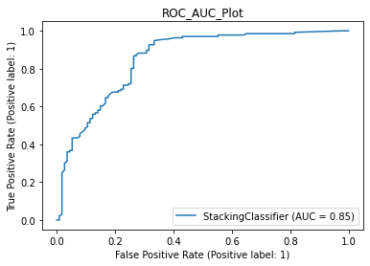
precision recall f1-score support

0 0.73 0.75 0.74 114
1 0.78 0.77 0.78 136

accuracy 0.76 250
macro avg 0.76 0.76 0.76 250
weighted avg 0.76 0.76 0.76 250

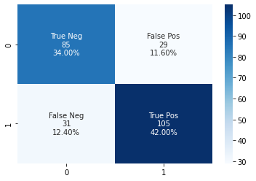

Alogrithm Results Table :

Unbalanced Dataset :
Sr. No. | ML Algorithm | Cross Validation Score | ROC AUC Score
1 | XGBClassifier | 83.60% | 67.16%
2 | LightGBMClassifier | 82.36% | 64.20%
3 | Stack of XGBClassifier & LightGBMClassifier | 80.15% | 65.70%

Balanced Dataset :
Sr. No. | ML Algorithm | Cross Validation Score | ROC AUC Score
1 | XGBClassifier | 86.71% | 78.60%
2 | LightGBMClassifier | 86.21% | 77.43%
3 | Stack of XGBClassifier & LightGBMClassifier | 84.35% | 75.88%
Conclusion

- This is a great dataset that helps us to look into a very special case study and look through the lens of data. It's target feature is in categorical format whereas the input features are in numerical format.
- Insights gained from the EDA section and the domain information match alot with a few mismatches. The domain information is generalized data whereas the EDA insights gathered are based on a demographic area.
- SMOTE analysis is used for data balancing. In order to highlight the performance difference when trained on unbalanced and balanced data, tree based models are trained.
- Performance of LGBM and XGB is neck to neck however the stack of the 2 classifiers did not outperform the other classifiers! Overall, a clear cut performance improvement can be observed when the models are trained on balanced dataset.

References :
- https://www.youtube.com/watch?v=pN4HqWRybwk
- https://www.britannica.com/topic/Pima-people
- https://pubmed.ncbi.nlm.nih.gov/7988310/
- https://pubmed.ncbi.nlm.nih.gov/8422798/
- Image Source
Please upvote if you learned something new!
Any sort of feedback is appreciated!
Thank You!

